**Title Self compatibility and asexual reproduction in an invasive buzz pollinated weed**

**Authors**

**Journal** *Biology letters* (research article – 3500 words + electronic supplementary material; max 3 figures + 3 tables; cover letter should also be uploaded to support your submission and that states why your research is novel; no page or colour charges)

*check SIMPLE PAST TENSE before sending and include citations/references.*

**Abstract (200-word limit)**

**Keywords (min. 3)** uniparental reproduction

**Introduction**

A plethora of research attempts to predict what general traits invasive species have in common to aid better management of invasive species. Invasion syndromes are a combination of pathways, alien species traits, and characteristics of the recipient ecosystem that collectively results in predictable dynamics and impacts of invasive species (Novoa et al. 2020). ~~I~~nvasion syndromes are gaining traction in the literature since they were first proposed by Perkins and Nowak (2013).

Invasion syndromes are a collation of small-scale, species-specific studies, which contain rigorous evidence that can collectively be synthesized to draw out broad shared traits among invasive species (Crawley 1987; Sun et al. 2013; Simberloff 2014 *in Novoa 2020*). Species possessing certain traits may be more susceptible to become invasive when introduced to new environments. For example, it has been hypothesized that plants with generalist pollination syndromes are more likely to become invasive compared to specialists ().

Pollination syndromes are broad sets of floral traits that enable predictions about their pollinator communities. Generalist or specialist pollination can vary depending on how they are defined (discussed in depth in Armbruster 2017). Here, we use “phenological” specialisation, because invasive traits used in pollination syndromes tend to align with the floral characteristics. Invasive angiosperms typically have large floral displays, showy flowers, and large amounts of floral rewards, making them attractive to a broad number of pollinators (Parra-Tabla and Arceo-Gomez 2021). Despite this, globally some plants that have specialist floral structures have become highly invasive.

One strategy to overcome the barrier of matching with a pollinator when introduced to a new area may be to reproduce in the absence of pollinators (Traveset). The reproductive assurance hypothesis predicts that selection favours self-pollination or asexual reproduction in flowering plants where pollinators or mates are scarce (Darwin, 1876; Baker, 1955), such as when colonising new habitats (Baker, 1955). Baker’s Law reiterates the reproductive assurance hypothesis and states that uniparental reproduction is advantageous for species when colonising island ecosystems by long-distance seed dispersal (Baker, 1955; Stebbins, 1957). A high proportion of invasive species have mixed mating systems (Korpelainen and Pietiläinen 2023); that is, plants can reproduce from the same parent which is beneficial under low population densities. Further, hand pollination experiments have shown that 73% (eight of the eleven Senna and Cassia studies which we have data for) can set seed from self-pollen. However, none of these studied Senna or Cassia species have been shown to set viable seed in the absence of a pollinator (natural or artificial pollination).

Poricidal anthers are a specialised floral morphological trait that have evolved in an estimated 10% of angiosperms and restrict pollen access. To efficiently extract pollen from poricidal anthers, an insect will vibrate its thorax muscles to produce an audible frequency which causes pollen release (). This coevolution between “buzzing” pollinators and poricidal anthers is known as the buzz-pollination syndrome. Globally, there are 94 angiosperm species that have poricidal anthers and have become invasive (reviewed by Lopresti *et al.* 2024). Yet, we are at the early stages of understanding what traits facilitate plant invasions for species with the buzz pollination syndrome.

In this study, we aim to assess the breeding system of an alien invasive plant with specialist floral morphology. *Senna obtusifolia* (Fabaceae) has poricidal anthers and exhibits the buzz pollination syndrome. *Senna obtusifolia* is native to the tropical Americas and has been introduced to every other continent except Antarctica. It has established and become invasive across much of the world’s tropical regions, including in Australia. Yet, the reproductive biology of *S. obtusifolia* in either the native or introduced ranges are largely unknown.

We addressed the following specific questions: (1) to what degree is *S. obtusifolia* physiologically self-compatible, (2) to what degree is *S. obtusifolia* functionally self-compatible, and (3) is *S. obtusifolia* pollen limited in either of its native or non-native ranges. We expect that *S. obtusifolia* can reproduce with self-pollen (physiologically self-compatible) and in the absence of pollinators (functionally self-compatible); and that selfing rates are higher in the invasive range compared to the native range. Further, we expect that *S.* *obtusifolia* will be pollen limited only in the non-native range.

**Methods**

*Study Sites*

This study was conducted *in situ* over one flowering season in each of *S. obtusifolia*’s native and non-native ranges. Native populations were studied between September and November 2023, at three sites in Yucatan, Mexico: Chochola, Tekik de Regil and Xmatkuil. Non-native populations were studied between April and August 2022, at five locations in Queensland, Australia: White Rock, Kamerunga, Trinity Beach, Springvale Station Nature Refuge and the West Normanby River (Table S1). Populations contained at least 50 *S. obtusifolia* plants. In the native range, populations were interspersed in plant communities that were dominated by *S. uniflora* on disturbed riparian corridors or farmland. In the non-native range, populations typically formed a monoculture, also on disturbed habitat riparian corridors or farmland.

*Breeding* ***system***

To determine the breeding system of *S. obtusifolia*, a series of pollination experiments were applied to 20 plants at each site. Flower buds near to opening were haphazardly selected and subjected to one of six randomly selected treatments: (1) open control (exposed to natural pollinators), (2) pollinator exclusion (mesh exclusion), (3) emasculated open (pollinator access without self-pollination), (4) emasculated closed (to test for apomixis and act as a control to emasculation treatments), (5) emasculated outcrosser (emasculate, bag to exclude natural pollinators, and hand pollinate with outsourced pollen), and (6) emasculated selfer (emasculate, bag to exclude natural pollinators, and hand pollinate with pollen sourced from the same individual). Each treatment was applied to an individual plant in the native range, while all of the six treatments were applied to the same plant in the non-native range and replicated on 20 plants per population, because the plants were smaller in the native range preventing all six replicates to be applied to most single plants. Treatments 3-6 were not applied at Springvale or the Normanby River sites due to time constraints. To ensure synchronicity of stigma receptivity within and among the treatments, flowers on a given plant were selected on the same day for all six treatments. White fine mesh bags (20 cm x 30 cm, or 16 cm x 23 cm) were used to exclude floral visitors during the experiment.

The open control was tagged and not manipulated. The pollinator exclusion treatment was bagged and not further manipulated. Emasculated open involved removing the anthers with foreceps prior to the stigma being receptive and the flower remained open to natural pollinators. Emasculated closed flowers also had the anthers removed prior to stigma receptivity and the flower was bagged. Emasculated outcrosser and emasculated selfer involved bagging the bud prior to flowers opening, and then hand pollinating each flower. Donor pollen was sourced on the day of hand pollination for the emasculated outcrosser and emasculated selfer treatments from flowers that had not been assigned a pollination treatment, from individuals at least 10 m away in the same population, or the same plant, respectively. Flowers were picked, and pollen was released using an electric toothbrush (Tayal *et al*., 2020). Released pollen was brushed onto the receptive stigma and pollen deposition was confirmed by visual inspection through a hand lens. Bags that were compromised during the experimental period, such as those where the branch broke, the bag tore, or there were signs of insect activity (such as frass), were excluded from the final analysis.

All flowers were monitored for reproductive success from the time of pollination to pod maturation. Pod development was defined as the swelling of the ovary after abscission of petals and stamens. Pod was classed as mature when a colour change was observed, and the pod was near to splitting. *Senna obtusifolia* pods matured within two months of pollination. Mature pods and seeds from each site were collected and counted to determine the number of seeds per pod. Seeds were classed as aborted (where the seed looked malformed) or viable. Reproductive success was defined as: 1) the percentage of flowers that produced a pod, and 2) the count of viable seeds per flower.

*Statistical analysis*

All data analyses were done in R (version 4.4.0). Due to differences in the field methods, we statistically analysed the data from each range independently and compared the results between the ranges qualitatively.

To examine whether fruit set varied among treatments we undertook two generalised linear mixed models with a binomial link function. Treatment was the predictor variable and fruit set was the response variable. For the native range data, we included site as a random effect. For the invasive range data, plant was nested in site and included as a random effect. We included an optimizer using a quadratic approximation to ensure the invasive range model converged. A Tukey HSD analysis was undertaken on each model to determine where the differences lay.

To determine whether seed set significantly differed among treatments we undertook an additional three generalised linear mixed models. In each model seed count per flower was the response variable and treatment was the fixed factor. The native range data was zero inflated so we used a negative binomial link function for this analysis. Further, in the native range one site (Chochola) had a much higher rate of zeros compared to the others. Consequently, we ran two analyses on the native range data and included site in both models as a zero inflated factor. For the first model we also included site as a fixed factor. This first model showed no significance difference among sites so we excluded site as a fixed factor from the second model. The AIC values demonstrated that the second model was the best fit for the data, so in this manuscript we present the results from the second model only: seed count per flower was the response variable and treatment was the fixed effect and site was included as a zero inflated variable. We undertook pairwise comparisons on select treatments to determine where the significant lay. We undertook a third GLMM with a Poisson distribution on the invasive range data. We included plant nested in site as a random effect and treatment was included as a zero inflated factor. We did a Tukey HSD analysis on this final model to determine between which treatments the differences lay.

**Results**

***Breeding system***

Fruit was produced at least once in all pollination treatments, although the number of flowers that set fruit varied broadly (Tables 1, S2, and S3; Fig. 1). In the native range, significantly fewer fruits were set when pollinators were excluded from the flowers (pollinator exclusion and emasculated closed) compared to other treatments, all of which were exposed to natural pollinators or artificially pollinated. Overall, a high number of fruits were set in the pollinator exclusion treatments (~25%) (Fig. 1) *compared to what*. There was no significant difference in fruit set between the open control and emasculate outcross treatment indicating *S. obtusifolia* was not pollen limited in the native range. Further, most fruit was set in the emasculate self treatment demonstrating that *S. obtusifolia* is self-compatible.

Similarly, in the invasive range some fruits were produced when pollinators were excluded from the flowers (pollinator exclusion and emasculate closed treatments) although, overall, fewer fruits were set from these treatments in the invasive range (<10%) compared to the native range (~25%) (Table 1; Fig. 1). In the invasive range, flowers exposed to natural pollinators set significantly fewer fruits compared to the emasculate outcross treatment, indicating that *S. obtusifolia* was pollen limited in the invasive range. Yet, there was no significant difference in fruit set between the emasculate outcross and emasculate selfing treatment demonstrating that *S. obtusifolia* is fully self-compatible. Interestingly, over half the flowers from the emasculate selfing treatment produced fruit in the native range, while less than 25% of flowers from this same treatment produced fruit in the invasive range (Fig. 1).

The number of viable seed produced by each flower varied among treatments (Table 1, and S4; Fig. 2). In the native range, fruits produced on average ~25 viable seeds per pod when exposed to natural pollinators, or hand pollinated with pollen sourced from the same plant or a different plant in the same population (emasculate outcross and emasculate selfing). Very few seeds were set when the flowers were emasculated and exposed to natural pollinators, or when the pollinators were excluded (pollinator exclusion and emasculate closed), although this was variable (Fig. 2).

In the invasive range, each fruit produced on average 16 seeds when hand pollinated (emasculate outcross and emasculate selfer), which did not significantly differ from flowers exposed to natural pollinators (open control and emasculate open) (Fig. 2). Few viable seed were set when pollinators were excluded from the flowers (pollinator exclusion and emasculate closed), although, overall, seed set from these treatments was highly variable (Fig. 2).

Table 1. Summary of results from the generalised linear mixed models for each response variable in each range.

|  |  |  |  |  |  |
| --- | --- | --- | --- | --- | --- |
| **Response variable** | **Range** | **Effect** | **Chisq** | **DF** | **Pr(>Chisq)** |
| Fruit:flower ratio | Native | Treatment | 30.39 | 5 | <0.001 |
| Fruit:flower ratio | Invasive | Treatment | 69.45 | 5 | <0.001 |
| Seed count (per flower) | Native | Treatment | 12.25 | 5 | 0.031 |
| Seed count (per flower) | Invasive | Treatment | 33.12 | 5 | <0.001 |

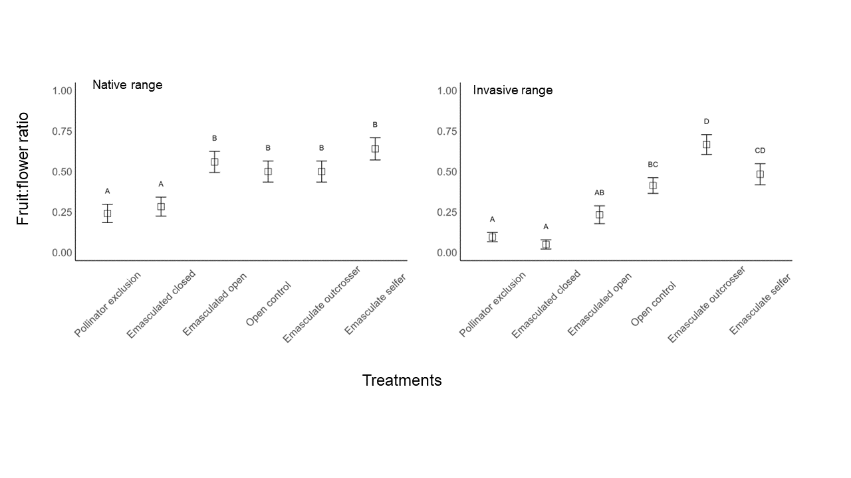**Figure 1. The mean (+-SE) number of flowers that set fruit after exposure to one of six pollination treatments. Data are pooled across sites within each range. Within each range, bars with different letters are significantly different, according to Tukey HSD analysis after a generalised linear mixed model.**

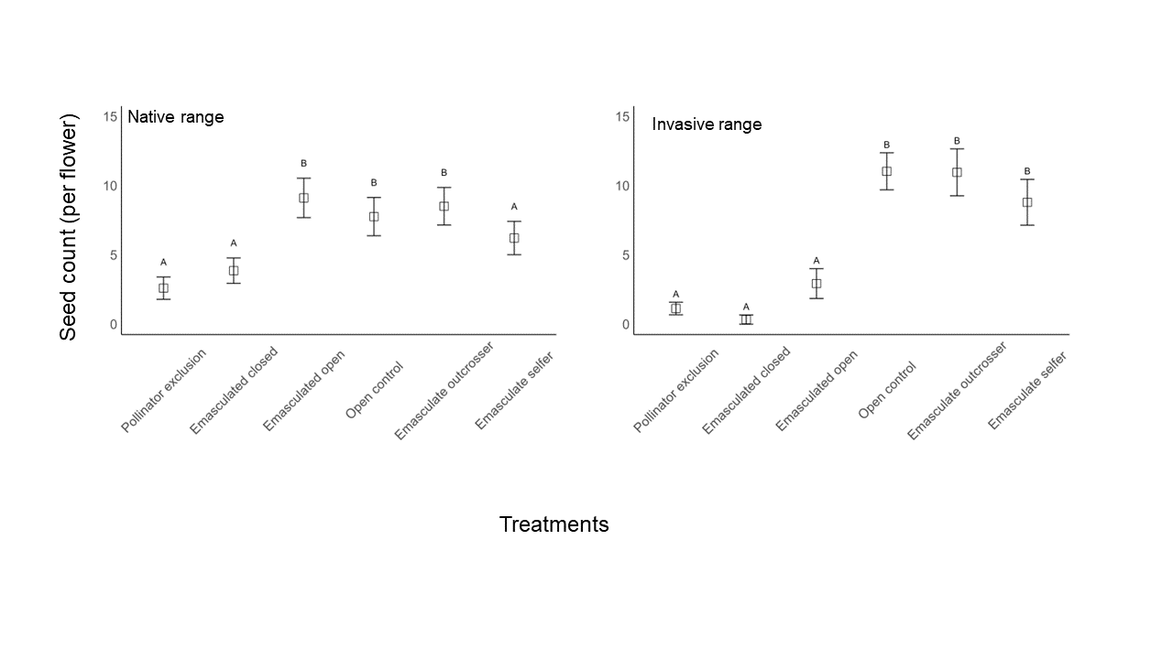**Figure 2: Mean (+-SE) count of seeds per flower after exposure to one of six manipulative pollination treatments. Data is pooled across sites within each range. Within each range, bars surmounted with different letters are significantly different, according to pairwise comparison where pollinator exclusion is the reference level (native range) and Tukey HSD analysis (invasive range) after a generalised linear mixed model.**

**Discussion**

***Senna obtusifolia* presented a mixed mating system, it was both physiologically and functionally self-compatible. A high degree of fruit was set when exposed to self-pollen in both its native and non-native ranges. *S. obtusifolia* can reproduce in the absence of pollinators in both its native and nonnative ranges, however few viable seeds were produced from flowers where pollen was excluded. *S. obtusifolia* was not pollen limited in the native range, but fruit set from the open pollination treatment was significantly less than the emasculate closed treatment in the invasive range, indicating that it was pollen limited in the invasive range.**

*Senna obtusifolia* has a mixed mating system and does not require pollinators for viable seed set. However, pollinators are likely important for the longevity of *S. obtusifolia* populations because significantly more seeds were set when pollen supply was supplemented or when it was exposed to natural pollinators compared to the pollinator exclusion treatments. Viable seeds were produced when the flowers were self-pollinated. Seed set data from the selfing treatment demonstrated a shift towards increase selfing in the invasive range compared to the native range. This may contribute to *S. obtusifolia’s* success as an invader because it does not need pollen from a different plant to reproduce. 🚩 This result provides general support for the reproductive assurance hypothesis which predicts that self-pollinating populations are superior colonizers of mate and pollinator scarce environments (~~Darwin, 1876; Baker, 1955~~) 🚩. *Enantiostylous discussion could fit well here.*

. It is also interesting that the patterns from the seed set data in the emasculate open treatment differed between the two ranges. In the native range, the emasculate open treatment set the same number of seed per pod because those exposed to natural pollinators and those that were hand pollinated; while in the invasive range, pods in the emasculate open treatment set very few viable seeds which was on par with the treatments where pollen was excluded from the flowers. This suggests that natural pollinators are attracted to and visiting the emasculated flowers in the native range and not in the invasive range. This may be a result of *fewer pollinators overall in the invasive range, or a different behaviour between pollinators in the ranges?? Does competition = individuals visiting damaged flowers??? To read. And build discussion from there*

Further, other hand pollination experiments have shown that 73% (eight of the eleven Senna and *Cassia* studies which we have data for) can set seed from self-pollen. However, none of these studied *Senna* or *Cassia* species have set viable seed in the absence of a pollinator (natural or artificial pollination). Yet, cytogenetic and molecular analyses have shown that some *Cassia* and *Senna* species have a high proportion of asexual offspring and can reproduce by apomixis (Randall 1970; Resende et al. 2014; Holamn and Playford 200; Delnevo et al. 2024). Our study is the first to our knowledge that has provided field evidence for likely viable seed set when pollinators were excluded from flowers in this genus.

**Hand pollinated flowers produced significantly more fruit compared to those open to natural pollinators in the invasive range, indicating that *Senna obtusifolia* was pollen limited in the invasive range only. When removed from coevolved pollinators, such as when plants are introduced into new world regions, they may not attract efficient pollinators. This has likely contributed to the pollen limitation because there was no difference in fruit set between hand pollinated and natural pollinated flowers in the native range. However, the plants in the invasive range were larger and field observations showed that the larger plants produced more flowers. Consequently, it is unlikely that the minor pollen limitation found in the invasive range inhibited invasion success because the plants in the invasive range produced more flowers.**

**Specialist pollination syndromes likely pose a barrier to invasions because the newly introduced species is less likely to attract pollinators when they require a specialist pollinator to reproduce. However, *S. obtusifolia* has overcome this potential barrier and it is invasive. Despite being pollen limited in the invasive range in Australia, nearly half of the unmanipulated flowers produced fruit and a prolific number (~28) of seed within each pod. Our result demonstrates that *S. obtusifolia* has found an adequate number of effective pollinators in the invasive range to reproduce and become invasive.**

**Further, the number of seeds produced per flower was on average 1.23 times greater in the invasive range compared to the native range when exposed to natural pollinators. This suggests that pollen viability was lower in the native range compared to the invasive range. Many factors can influence viable pollen production including drought stress, heat stress, nutrient poor soils (). The plants in the native range were exposed to extreme heat stress throughout the experiment and temperature were on average 3*C warmer for the duration of the experiment, compared to the invasive range (*ref*). This heat stress has perhaps reduced the number of available viable pollen grains in the native range. A common garden experiment with seeds sourced from both the native and invasive range would aid in identifying whether heat stress can reduce viable seed set in this species.**

Our study has provided support for the reproductive assurance hypothesis because *S. obtusifolia* can set viable seed from self-pollen and reproduce asexually. We found that *S. obtusifolia* can set viable some seed in the absence of pollinators altogether, which likely contributes to its invasion success. This is particularly important because it exhibits the specialised buzz pollination syndrome. When introduced to a new region, *S. obtusifolia* does not need to find pollinators that can access pollen from poricidal anthers to set seed and reproduce. Finally, our study demonstrated that *S. obtusifolia* was pollen limited in its invasive range, but a significant number of viable seed was still produced so it is unlikely that this prevents invasion success. The next logical steps are to determine whether *S. obtusifolia* is seed limited and the likely viable seeds observed here, do, in fact germinate.

**Author contributions**

**Acknowledgements field assistants/Abiel.**

**Funding information ATH, CSE, and ATBC grants; Laura C. Lopresti was supported by the Australian Government Research Training Program Scholarship.**

**Ethics statement We were not required to complete an ethical assessment prior to conducting our research.**

**Competing interests statement We declare we have no competing interests.**

**Data accessibility statement The data sets and code generated during the current study are archived in the Research Data Australia repository and are publicly available: *DOI to be added***

**Artificial Intelligence (AI) declaration We have not used AI-assisted technologies in creating this article.**

**References**

**“it was also found that Senna is rather a heterogeneous taxon”**

(Randall 1970; Resende et ai/ 2014; Holamn and Playford 200; Delnevo et al. 2024)

**Supplementary data**

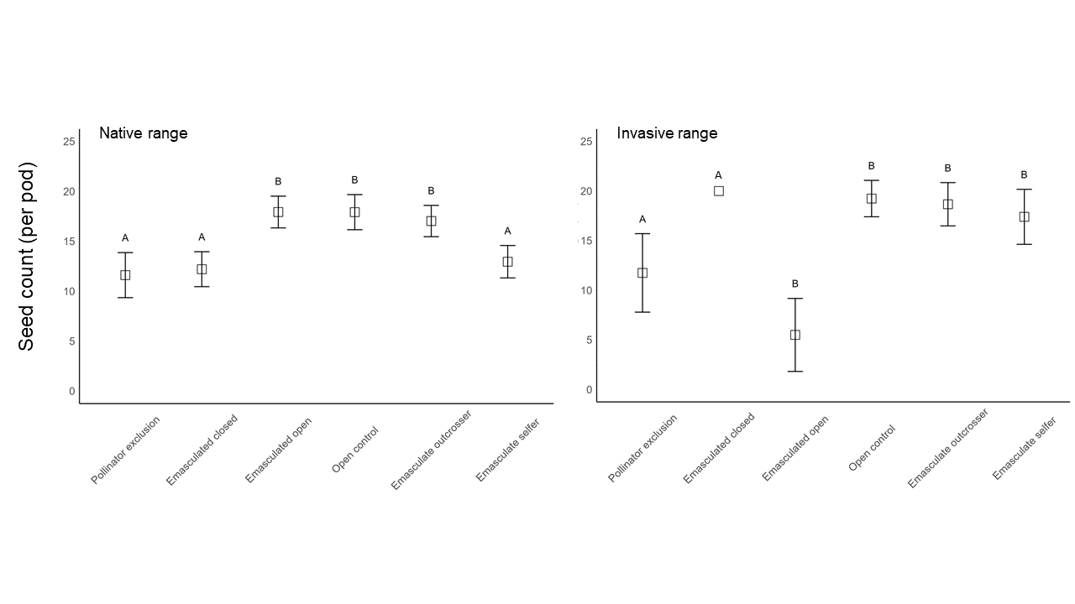**Figure S1 Mean (+-SE) count of seeds per pod after exposure to one of six manipulative pollination treatments. Data is pooled across sites within each range. Within each range, bars surmounted with different letters are significantly different, according to pairwise comparison where pollinator exclusion is the reference level after a generalised linear mixed model.**

**Table S1 *Senna obtusifolia* populations used in the study.**

|  |  |  |
| --- | --- | --- |
| **Population** | **Latitude** | **Longitude** |
| Trinity Beach QLD, Australia | -1343.54672 | 11654.73632 |
| White Rock QLD, Australia | -2377.614571 | 20405.26943 |
| Freshwater QLD, Australia | -1315.055979 | 11365.69191 |
| Barron River QLD, Australia | -16.86610636 | 145.6950007 |
| **Springvale, QLD, Australia** |  |  |
| **West Normanby River, QLD, Australia** |  |  |
| Chochola Municipality, Yucatan, Mexico | 1328.015122 | -5747.787663 |
| Xmatikuil, Yucatan, Mexico | 1877.237486 | -8066.311543 |
| Tekik de Regil, Yucatan, Mexico | 1956.339748 | -8420.450241 |

**Table S2.** Results from the generalised linear mixed models for each response variable in each range.

|  |  |  |  |  |  |  |  |
| --- | --- | --- | --- | --- | --- | --- | --- |
| **Response variable** | **Range** | **Effect** | **Estimate** | **St. dev** | **Chisq** | **DF** | **Pr(>Chisq)** |
| Fruit:flower ratio | Native | Site (random) | 1.63 | 1.28 |  |  |  |
| Fruit:flower ratio | Native | Treatment |  |  | 30.39 | 5 | <0.001 |
| Fruit:flower ratio | Invasive | Site (random) | 0.57 | 0.75 |  |  |  |
| Fruit:flower ratio | Invasive | Plant:site (random) | 0.08 | 0.28 |  |  |  |
| Fruit:flower ratio | Invasive | Treatment |  |  | 69.45 | 5 | <0.001 |
| Seed count (per flower) | Native | Treatment |  |  | 12.25 | 5 | 0.031 |
| Seed count (per flower) | Invasive | Site (random) | <0.001 | <0.001 |  |  |  |
| Seed count (per flower) | Invasive | Plant:site (random) | <0.001 | <0.001 |  |  |  |
| Seed count (per flower) | Invasive | Treatment |  |  | 33.12 | 5 | <0.001 |

**Table S3.** Tukey test outputs following generalised linear mixed model where native and invasive range data were analysed in two different models. The number of flowers that produced fruit was the response variable and the treatment applied was the fixed effect.

|  |  |  |  |  |  |  |
| --- | --- | --- | --- | --- | --- | --- |
| **Contrast** | **Range** | **estimate** | **SE** | **df** | **z.ratio** | **p.value** |
| Emasculate outcrosser - Emasculate selfer | Native | -4.93E-01 | 0.457 | Inf | -1.079 | 0.89 |
| Emasculate outcrosser - Emasculated closed | Native | 1.17E+00 | 0.435 | Inf | 2.7 | 0.0752 |
| Emasculate outcrosser - Emasculated open | Native | -3.52E-01 | 0.436 | Inf | -0.808 | 0.9662 |
| Emasculate outcrosser - Open control | Native | 4.10E-06 | 0.427 | Inf | 0 | 1 |
| Emasculate outcrosser - Pollinator exclusion | Native | 1.44E+00 | 0.448 | Inf | 3.209 | 0.0168 |
| Emasculate selfer - Emasculated closed | Native | 1.67E+00 | 0.465 | Inf | 3.584 | 0.0046 |
| Emasculate selfer - Emasculated open | Native | 1.41E-01 | 0.465 | Inf | 0.303 | 0.9997 |
| Emasculate selfer - Open control | Native | 4.93E-01 | 0.457 | Inf | 1.079 | 0.89 |
| Emasculate selfer - Pollinator exclusion | Native | 1.93E+00 | 0.478 | Inf | 4.043 | 0.0008 |
| Emasculated closed - Emasculated open | Native | -1.53E+00 | 0.447 | Inf | -3.42 | 0.0082 |
| Emasculated closed - Open control | Native | -1.17E+00 | 0.435 | Inf | -2.7 | 0.0752 |
| Emasculated closed - Pollinator exclusion | Native | 2.63E-01 | 0.451 | Inf | 0.584 | 0.9921 |
| Emasculated open - Open control | Native | 3.52E-01 | 0.436 | Inf | 0.808 | 0.9662 |
| Emasculated open - Pollinator exclusion | Native | 1.79E+00 | 0.459 | Inf | 3.896 | 0.0014 |
| Open control - Pollinator exclusion | Native | 1.44E+00 | 0.448 | Inf | 3.209 | 0.0168 |
| Emasculate outcrosser - Emasculate selfer | Invasive | 0.904 | 0.415 | Inf | 2.181 | 0.2467 |
| Emasculate outcrosser - Emasculated closed | Invasive | 4.043 | 0.696 | Inf | 5.813 | <.0001 |
| Emasculate outcrosser - Emasculated open | Invasive | 2.19 | 0.46 | Inf | 4.761 | <.0001 |
| Emasculate outcrosser - Open control | Invasive | 1.502 | 0.415 | Inf | 3.624 | 0.0039 |
| Emasculate outcrosser - Pollinator exclusio | Invasive | 3.538 | 0.518 | Inf | 6.835 | <.0001 |
| Emasculate selfer - Emasculated closed | Invasive | 3.139 | 0.673 | Inf | 4.663 | <.0001 |
| Emasculate selfer - Emasculated open | Invasive | 1.286 | 0.432 | Inf | 2.973 | 0.0349 |
| Emasculate selfer - Open control | Invasive | 0.598 | 0.387 | Inf | 1.546 | 0.6344 |
| Emasculate selfer - Pollinator exclusion | Invasive | 2.634 | 0.487 | Inf | 5.408 | <.0001 |
| Emasculated closed - Emasculated open | Invasive | -1.853 | 0.68 | Inf | -2.725 | 0.0703 |
| Emasculated closed - Open control | Invasive | -2.541 | 0.657 | Inf | -3.866 | 0.0015 |
| Emasculated closed - Pollinator exclusion | Invasive | -0.505 | 0.707 | Inf | -0.715 | 0.9802 |
| Emasculated open - Open control | Invasive | -0.688 | 0.414 | Inf | -1.662 | 0.5572 |
| Emasculated open - Pollinator exclusion | Invasive | 1.348 | 0.497 | Inf | 2.713 | 0.0727 |
| Open control - Pollinator exclusion | Invasive | 2.036 | 0.405 | Inf | 5.022 | <.0001 |

**Table S4.** Posthoc analyses after generalised linear mixed model where native and invasive range data were analysed in two different models. The count of seeds produced by each flower was the response variable and the treatment applied was the fixed effect. Invasive range posthoc was based on a Tukeys test and the native range pos hoc were based on select pairwise comparisons.

|  |  |  |  |  |  |  |
| --- | --- | --- | --- | --- | --- | --- |
| **Contrast** | **Range** | **estimate** | **SE** | **df** | **z.ratio** | **p.value** |
| Emasculate outcrosser - Emasculate selfer | Invasive | -0.15628 | 0.0832 | Inf | -1.877 | 0.4161 |
| Emasculate outcrosser - Emasculated closed | Invasive | 0.038181 | 0.4007 | Inf | 0.095 | 1 |
| Emasculate outcrosser - Emasculated open | Invasive | -0.03166 | 0.1822 | Inf | -0.174 | 1 |
| Emasculate outcrosser - Open control | Invasive | -0.15588 | 0.0757 | Inf | -2.058 | 0.3096 |
| Emasculate outcrosser - Pollinator exclusion | Invasive | 0.425075 | 0.1459 | Inf | 2.914 | 0.0416 |
| Emasculate selfer - Emasculated closed | Invasive | 0.194458 | 0.4028 | Inf | 0.483 | 0.9968 |
| Emasculate selfer - Emasculated open | Invasive | 0.124623 | 0.1878 | Inf | 0.664 | 0.9858 |
| Emasculate selfer - Open control | Invasive | 0.000394 | 0.0865 | Inf | 0.005 | 1 |
| Emasculate selfer - Pollinator exclusion | Invasive | 0.581352 | 0.1504 | Inf | 3.864 | 0.0016 |
| Emasculated closed - Emasculated open | Invasive | -0.06984 | 0.4349 | Inf | -0.161 | 1 |
| Emasculated closed - Open control | Invasive | -0.19406 | 0.3987 | Inf | -0.487 | 0.9966 |
| Emasculated closed - Pollinator exclusion | Invasive | 0.386894 | 0.4178 | Inf | 0.926 | 0.94 |
| Emasculated open - Open control | Invasive | -0.12423 | 0.1838 | Inf | -0.676 | 0.9846 |
| Emasculated open - Pollinator exclusion | Invasive | 0.45673 | 0.2239 | Inf | 2.04 | 0.3197 |
| Open control - Pollinator exclusion | Invasive | 0.580958 | 0.1381 | Inf | 4.205 | 0.0004 |
| Pollinator_exclusion_vs_Emasculate_selfer | Native | 0.1761 | 0.203 | Inf | 0.868 | 0.3856 |
| Pollinator_exclusion_vs_Emasculated_closed | Native | -0.0739 | 0.214 | Inf | -0.346 | 0.7296 |
| Pollinator_exclusion_vs_Emasculated_open | Native | -0.4414 | 0.19 | Inf | -2.32 | 0.0203 |
| Pollinator_exclusion_vs_Open_control | Native | -0.5029 | 0.193 | Inf | -2.61 | 0.0091 |
| Emasculate_outcrosser_vs_Pollinator_exclusion | Native | -0.4491 | 0.191 | Inf | -2.356 | 0.0184 |
| Pollinator_exclusion_vs_Emasculate_selfer | Native | 0.273 | 0.139 | Inf | 1.967 | 0.0492 |